**1.**

**[ASUS ZENBOOK PRO DUO](https://www.digit.in/laptops/asus-zenbook-pro-duo-ux581-price-191126.html)**

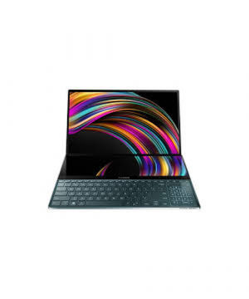

* OS

OS

WINDOWS 10 PRO

* Display

DISPLAY

15.6" (3840 X 2160)

* Processor

PROCESSOR

INTEL® CORE™ I9-9980HK PROCESSOR | 2.4 GHZ

* Memory

MEMORY

256 GB NA/8 GBGB DDR4

FULL SPECS

Powered by an Intel 9th Gen Core i9 CPU, the ZenBook Pro Duo was unveiled a few days ahead of the 2019 Computex. It builds on the ZenBook Pro 15 by sporting a much larger, more usable second screen.

|  |
| --- |
|  |
| SPECIFICATION | | | |
| OS | : | Windows 10 Pro | |
| Display | : | 15.6" (3840 x 2160) | |
| Processor | : | Intel® Core™ i9-9980HK processor | 2.4 GHz | |
| Memory | : | 256 GB NA/8 GBGB DDR4 | |
| Weight | : | 2.5 | |
| Dimension | : | 359 x 246 x 24 | |
| Graphics Processor | : | NVIDIA Geforce RTX 2060 | |
| flipkart | **AVAILABLE** | **265980** | BUY NOW |
| amazon | **AVAILABLE** | **269000** | BUY NOW |

**2.**

**[HP SPECTRE X360 13](https://www.digit.in/laptops/hp-spectre-x360-13-price-192476.html)**

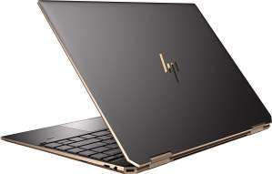

* OS

OS

WINDOWS 10 PRO

* Display

DISPLAY

13.3" (1920 X 1080)

* Processor

PROCESSOR

I7-8565U | 1.8

* Memory

MEMORY

NA NULL/16 GBGB NULL

The HP Spectre x360 13 is now much smaller and lighter than ever before. Its bezels have thinned down heavily, while its CPU has been upgraded to Intel's 10th Gen series. The HP Spectre x360 13 is particularly known for its long battery life.

|  |
| --- |
|  |
| SPECIFICATION | | |
| OS | : | Windows 10 Pro |
| Display | : | 13.3" (1920 x 1080) |
| Processor | : | i7-8565U | 1.8 |
| Memory | : | NA null/16 GBGB null |
| Weight | : | 1.3 |
| Dimension | : | NA |
| Graphics Processor | : | Intel UHD Graphics 620 |

**3.**

**[ASUS TUF GAMING A15](https://www.digit.in/laptops/asus-tuf-gaming-a15-price-201669.html)**

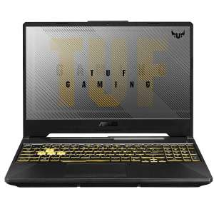

* OS

OS

WINDOWS 10 PRO

* Display

DISPLAY

15.6" (2160 X 1080)

* Processor

PROCESSOR

NA

* Memory

MEMORY

256 GB + + 1TB SSD SSD/NA DDR4

The Asus TUF Gaming A15 is powered by AMD’s Ryzen 7 4800H processor. This chip is manufactured on the 7nm process and packs 8 coores and 16 threads that chug along at a 2.9GHz base clock and go up to 4.2GHz on boost. The processor is also power-efficient thanks to the new manufacturing process. The laptop delivers solid performance thanks to the processor and GPU combo, along with offering users the ability to perform significant upgrades to memory and storage.

|  |
| --- |
|  |
| SPECIFICATION | | |
| OS | : | Windows 10 Pro |
| Display | : | 15.6" (2160 x 1080) |
| Processor | : | NA |
| Memory | : | 256 GB + + 1TB SSD SSD/NA DDR4 |
| Weight | : | 2.3 |
| Dimension | : | 359.8 x 256 x 22.8 |
| Graphics Processor | : | AMD® Ryzen™ 7 4800H |
| Price | : | ₹60990 |

Advertisements

**4.**

**[LENOVO IDEAPAD C340](https://www.digit.in/laptops/lenovo-ideapad-c340-price-192112.html)**

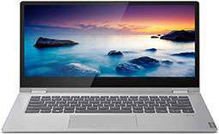

* OS

OS

WINDOWS 10 HOME

* Display

DISPLAY

14" (1920 X 1080)

* Processor

PROCESSOR

INTEL CORE I3-8145U | 2.1

* Memory

MEMORY

512 4/4GB SDRAM

Here's proof that Lenovo's 2019 IdeaPad can in fact do Yoga. The IdeaPad C340 is a convertible laptop that's not shy to do graphic work because it sports an Nvidia GeForce MX230 graphics card. It comes powered by either an Intel Core series or AMD Ryzen series processor.

|  |
| --- |
|  |
| SPECIFICATION | | | |
| OS | : | | Windows 10 Home |
| Display | : | | 14" (1920 x 1080) |
| Processor | : | | Intel Core i3-8145U | 2.1 |
| Memory | : | | 512 4/4GB SDRAM |
| Weight | : | | 1.65 |
| Dimension | : | | 328 x 229 x 17.9 |
| Graphics Processor | : | | Intel Integrated UHD |
| flipkart | **AVAILABLE** | **52998** | BUY NOW |
| amazon | **AVAILABLE** | **58990** | BUY NOW |

**5.**

**[DELL XPS 15](https://www.digit.in/laptops/dell-xps-15-price-106743.html)**

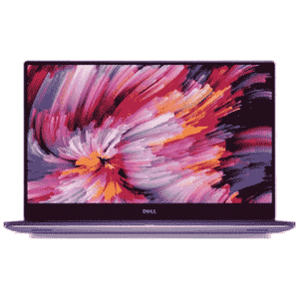

* OS

OS

WINDOWS 10 HOME

* Display

DISPLAY

15.6" (1920 X 1080)

* Processor

PROCESSOR

7TH GENERATION INTEL CORE I7-7700HQ | 3.8 GHZ

* Memory

MEMORY

256 GB SSD/4GB GDDR5

The Dell XPS has remained a worthy competitor to Apple’s MacBook and this year as well the newer XPS 15 stands head and shoulders above the competition. The Dell XPS 15 is an amalgamation of everything you would ever need from a mainstream laptop. It has the performance of a gaming laptop, the battery life of an Ultrabook and an industrial design which is tried and tested in the years past.

|  |
| --- |
|  |
| SPECIFICATION | | | |
| OS | : | Windows 10 Home | |
| Display | : | 15.6" (1920 X 1080) | |
| Processor | : | 7th Generation Intel Core i7-7700HQ | 3.8 GHz | |
| Memory | : | 256 GB SSD/4GB GDDR5 | |
| Weight | : | 1.8 | |
| Dimension | : | NA | |
| Graphics Processor | : | NVIDIA GeForce GTX 1050 | |
| amazon | **AVAILABLE** | **198990** | BUY NOW |

**6.**

**[ASUS ZENBOOK PRO](https://www.digit.in/laptops/asus-zenbook-pro-15-price-135198.html)**

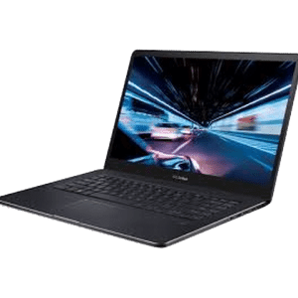

* OS

OS

WINDOWS 10 HOME

* Display

DISPLAY

15.6" (3840 X 2160)

* Processor

PROCESSOR

INTEL CORE I9-8950HK | 2.9 GHZ

* Memory

MEMORY

1 TB SSD/16GB DDR4

[READ REVIEW](https://www.digit.in/reviews/laptops/asus-zenbook-pro-15-review-135198.html)

FULL SPECS

The Asus ZenBook Pro is a powerful machine for photo and video editing. Though it might appear as a gimmick at first, the ScreenPad actually manages to help you work faster at times. The audio and the display quality are a proper boss on this model.

|  |
| --- |
|  |
| SPECIFICATION | | | |
| OS | : | | Windows 10 Home |
| Display | : | | 15.6" (3840 x 2160) |
| Processor | : | | Intel Core i9-8950HK | 2.9 GHz |
| Memory | : | | 1 TB SSD/16GB DDR4 |
| Weight | : | | 1.88 |
| Dimension | : | | 18.9 x 365 x 251 |
| Graphics Processor | : | | NVIDIA Geforce GTX 1050Ti |
| flipkart | **AVAILABLE** | **204990** | BUY NOW |

Advertisements

**7.**

**[ASUS ZENBOOK 14 (UM431)](https://www.digit.in/laptops/asus-zenbook-14-um431-price-191594.html)**

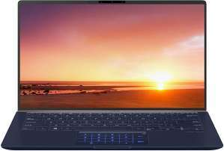

* OS

OS

WINDOWS 10 HOME

* Display

DISPLAY

14" (1920 X 1080)

* Processor

PROCESSOR

AMD® RYZENTM R5-3500U | NA

* Memory

MEMORY

512 GB NA/8GB DDR4

The Asus ZenBook 14 (UM431) is an AMD Ryzen-powered laptop that's ideal for users who crave power and portability equally. Its all-metal body, coloured in a classy new sliver colour, is arguably one of the most attractive out there in this segment.

|  |
| --- |
|  |
| SPECIFICATION | | | |
| OS | : | Windows 10 Home | |
| Display | : | 14" (1920 x 1080) | |
| Processor | : | AMD® RyzenTM R5-3500U | NA | |
| Memory | : | 512 GB NA/8GB DDR4 | |
| Weight | : | 1.39 | |
| Dimension | : | 323.5 x 211.85 x 15.9 | |
| Graphics Processor | : | Integrated AMD® Radeon RX Vega 8 | |
| flipkart | **AVAILABLE** | **56990** | BUY NOW |
| amazon | **AVAILABLE** | **59490** | BUY NOW |

**8.**

**[LENOVO IDEAPAD S540](https://www.digit.in/laptops/lenovo-ideapad-s540-15-inch-price-186212.html)**

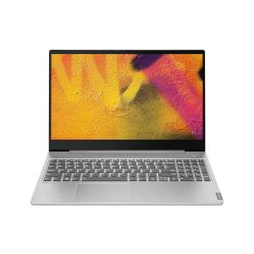

* OS

OS

WINDOWS 10 HOME

* Display

DISPLAY

15" (1920 X 1080)

* Processor

PROCESSOR

UP TO 8TH GEN INTEL® CORE™ I5 | 1.8 GHZ

* Memory

MEMORY

128 GB SSD/UP TO 12GB DDR4

The IdeaPad S540 from Lenovo is the model to go for if you are in the market for a powerful 15-inch laptop that is also slim and lightweight. It is highly rated for its bright, colourful display and crisp precision touchpad.

|  |
| --- |
|  |
| SPECIFICATION | | | |
| OS | : | Windows 10 Home | |
| Display | : | 15" (1920 X 1080) | |
| Processor | : | Up to 8th Gen Intel® Core™ i5 | 1.8 Ghz | |
| Memory | : | 128 GB SSD/up to 12GB DDR4 | |
| Weight | : | 1.8 | |
| Dimension | : | 358 mm x 245 mm x 16.95 mm | |
| Graphics Processor | : | Intel® integrated graphics | |
| amazon | **AVAILABLE** | **70999** | BUY NOW |

**9.**

**[LENOVO THINKPAD X1 EXTREME](https://www.digit.in/laptops/lenovo-thinkpad-x1-extreme-price-173539.html)**

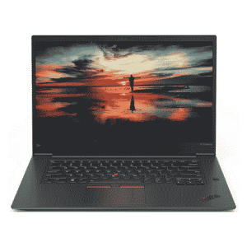

* OS

OS

WINDOWS 10 PRO

* Display

DISPLAY

15.6" (1920 X 1080)

* Processor

PROCESSOR

UP TO 8TH GEN INTEL® CORE™ FL-H I5/I7 VPRO | 2.2 GHZ

* Memory

MEMORY

512 GB SATA/16GB DDR4

[READ REVIEW](https://www.digit.in/reviews/laptops/lenovo-thinkpad-x1-extreme-review-173539.html)

FULL SPECS

As its name suggests, everything about the new 15.6-inch ThinkPad is extreme. It sports an 8th-gen Intel Core i7 CPU, has up to 64GB of RAM, can take up to two PCIe-based SSDs, and has an NVIDIA GeForce GTX 1050 GPU for graphics. It's beastly!

|  |
| --- |
|  |
| SPECIFICATION | | | |
| OS | : | Windows 10 Pro | |
| Display | : | 15.6" (1920 x 1080) | |
| Processor | : | Up to 8th Gen Intel® Core™ FL-H i5/i7 vPro | 2.2 Ghz | |
| Memory | : | 512 GB SATA/16GB DDR4 | |
| Weight | : | 1.7 | |
| Dimension | : | 361.8 x 245.7 x 18.4 | |
| Graphics Processor | : | NVIDIA GTX1050Ti GDDR5 4G 4GB GDDR5 | |
| amazon | **AVAILABLE** | **258542** | BUY NOW |

Advertisements

**10.**

**[ASUS VIVOBOOK X403](https://www.digit.in/laptops/asus-vivobook-x403-price-187640.html)**

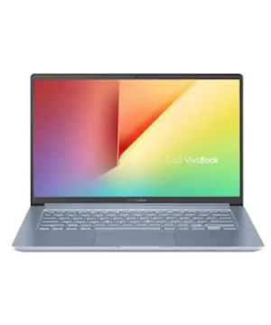

* OS

OS

WINDOWS 10 PRO

* Display

DISPLAY

14" (1920 X 1080)

* Processor

PROCESSOR

INTEL CORE I5 8TH GEN 8265U | 1.6

* Memory

MEMORY

1 TB SATA HDD/8GB SDRAM

The Asus VivoBook X403 takes on thin and light models with a super-long battery life like the Apple MacBook Air by sporting a 72Wh battery. Thanks to its Intel 8th Gen Core i5 CPU that's combined with 8GB RAM, everyday performance is good too.

|  |
| --- |
|  |
| SPECIFICATION | | | |
| OS | : | Windows 10 Pro | |
| Display | : | 14" (1920 x 1080) | |
| Processor | : | Intel Core i5 8th Gen 8265U | 1.6 | |
| Memory | : | 1 TB SATA HDD/8GB SDRAM | |
| Weight | : | 1.3 | |
| Dimension | : | 208.48 x 322.86 x 16.50 | |
| Graphics Processor | : | Integrated Intel HD Graphics 620 | |
| flipkart | **AVAILABLE** | **51990** | BUY NOW |
| amazon | **AVAILABLE** | **57500** | BUY NOW |